Given Set01 folder (ask Invigilator) that contains required files for 2 web page naming: Home.html and NewAccount.html.
The Home.html page has the interface as shown in the Figure 1:
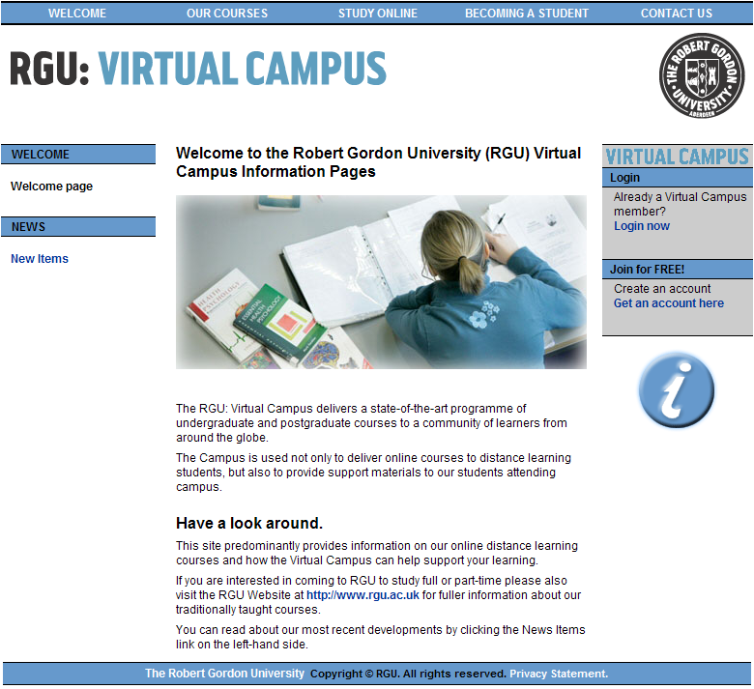

Figure 1

- Create a hyperlink for the “Get an account here” text so [2]
when the user click on it, the browser opens the NewAccount.html page.
- The NewAccount.html page has the interface as shown in the Figure 2.
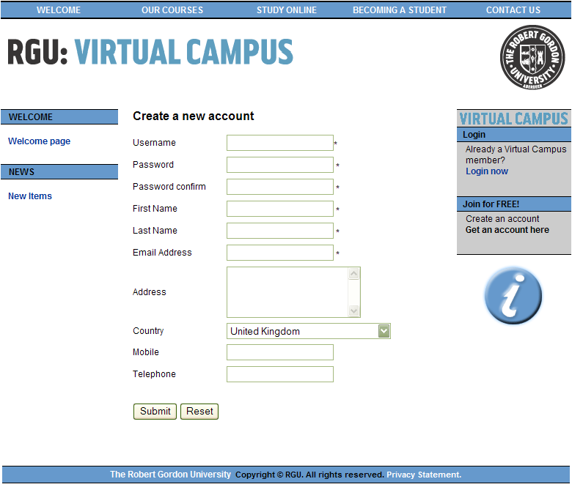

Write the scripts to perform the following tasks:
- Fill the Country combo box with the following data: [2]

Thailand
Malaysia
Japan
Vietnam

- When the user click on the Submit button, perform the following tasks:
  - If the user doesn’t type anything in the User Name, Password, [6]
Password Confirm, First Name, Last Name or Email Address fields,
a appropriate message box should be displayed as:
(1 mark for each field)
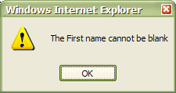

  - When the user clicks on the OK button, the focus should be [3]
set to the blank field (0.5 mark for each field)
  - The length of the User Name field must be from 6 to 12 characters [1]
  - The length of the Password field must be from 6 to 12 characters. [1]
  - The value of the Password field must be differ
from the value of the User Name field [2]
  - The value of the Password and Password Confirm must be the same [2]
  - The Email Address field must be in format xxxx@xxx.xxx [2]
  - The Mobile and Telephone fields (if any) must be digits only. [4]
(2 marks for each field)
  - If the data is valid, display a message box to inform [1]
the user as the following:

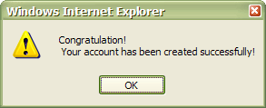

  - When the user clicks on the OK button, the browser opens the [1]
Home.html again
- When the Reset Button is clicked, all field on the form will be clear [1]
- Create a hyperlink for the “Welcome page” text so when the user click on it, [2]
the browser opens the Home.html page again.

NOTE: Any change to the structure or format of the Web pages result in the lower score

